SET 4: PRODUCT INVENTORY MANAGEMENT
Course: DSA0601 – Data Handling and Visualization using R

Aim
To analyze and visualize product inventory data using R programming and create an interactive Tableau dashboard.
Dataset
Product ID | Product Name | Quantity Available
1 | Product A | 250
2 | Product B | 175
3 | Product C | 300
4 | Product D | 200
5 | Product E | 220
1. PROGRAM 1: BAR CHART
Aim: To create a bar chart showing the quantity available for each product.
product_name <- c("Product A", "Product B", "Product C", "Product D", "Product E")
quantity_available <- c(250, 175, 300, 200, 220)
bars <- barplot(
quantity_available,
names.arg = product_name,
main = "Product Inventory Quantity",
xlab = "Product Name",
ylab = "Quantity Available",
col = c("skyblue", "lightgreen", "orange", "pink", "violet")
)
text(bars, quantity_available, labels = quantity_available, pos = 3)
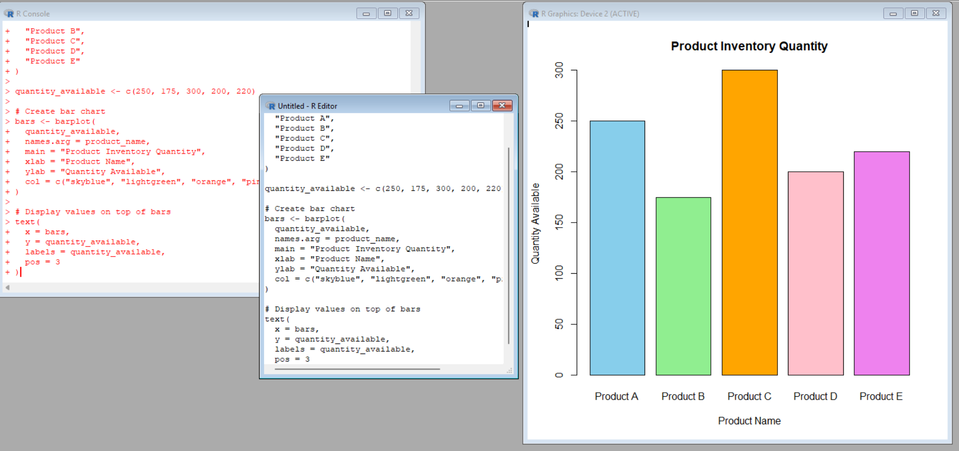
Explanation
barplot() creates the chart; names.arg labels products; main gives the title; xlab and ylab label the axes; col gives colors; text() displays values above the bars.
Observation
Product C has the highest quantity (300), while Product B has the lowest quantity (175).
PROGRAM 2: STACKED BAR CHART
Note: Product Category is not present in the original dataset. The categories below are illustrative values added only to demonstrate the required chart.
product_name <- c("Product A", "Product B", "Product C", "Product D", "Product E")
category <- c("Electronics", "Electronics", "Grocery", "Grocery", "Electronics")
quantity_available <- c(250, 175, 300, 200, 220)
inventory_category <- data.frame(
Product_Name = product_name,
Category = category,
Quantity_Available = quantity_available
)
category_data <- xtabs(
Quantity_Available ~ Product_Name + Category,
data = inventory_category
)
barplot(
t(category_data),
beside = FALSE,
main = "Product Quantity by Category",
xlab = "Product Name",
ylab = "Quantity Available",
col = c("skyblue", "orange"),
legend.text = TRUE
)
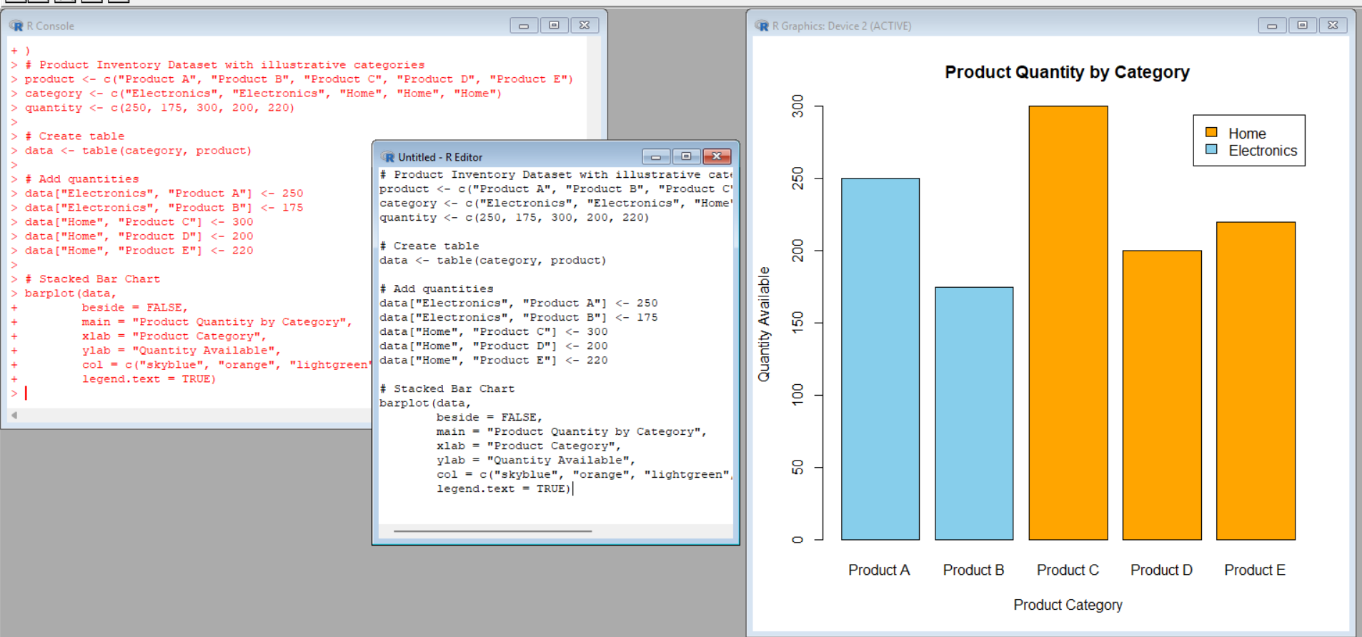
Explanation
xtabs() organizes quantity by product and category. barplot() creates the stacked chart. beside = FALSE stacks the categories, and legend.text = TRUE displays the legend.
Observation
The chart shows each product's available quantity with its illustrative product category.
PROGRAM 3: SCATTER PLOT
Note: Product Price is not present in the original dataset. The prices below are illustrative values used only for demonstrating the scatter plot.
product_name <- c("Product A", "Product B", "Product C", "Product D", "Product E")
product_price <- c(100, 150, 80, 120, 110)
quantity_available <- c(250, 175, 300, 200, 220)
plot(
product_price,
quantity_available,
main = "Product Price vs Quantity Available",
xlab = "Product Price",
ylab = "Quantity Available",
pch = 19,
col = "blue"
)
text(product_price, quantity_available, labels = product_name, pos = 3)
model <- lm(quantity_available ~ product_price)
abline(model, col = "red", lwd = 2)
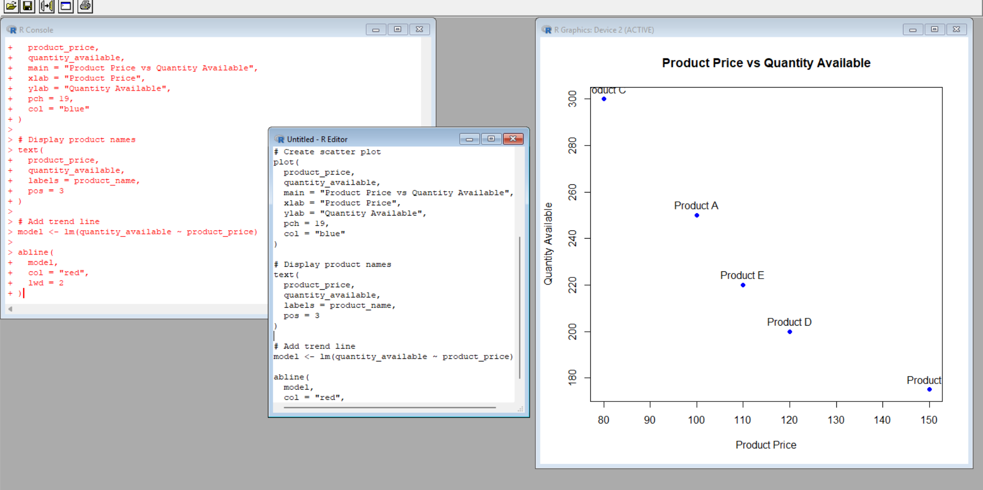
Explanation
plot() creates the scatter plot, with each point representing one product. text() labels the points. lm() fits a simple linear model and abline() adds the trend line.
Observation
For these illustrative prices, the points show a generally negative relationship: higher prices tend to be associated with lower available quantities. This does not establish causation, and the prices are not original dataset values.
PROGRAM 4: TABLEAU DASHBOARD
Aim: To create an interactive Tableau dashboard containing the product quantity bar chart and category-wise stacked bar chart.
Step 1: Create Excel Dataset
Create Product_Inventory.xlsx with the following fields: Product ID, Product Name, Quantity Available, Product Category, Product Price.
Illustrative category/price values:
ID | Product | Quantity | Category | Price
1 | Product A | 250 | Electronics | 100
2 | Product B | 175 | Electronics | 150
3 | Product C | 300 | Grocery | 80
4 | Product D | 200 | Grocery | 120
5 | Product E | 220 | Electronics | 110
Step 2: Open Tableau
- Open Tableau Desktop or Tableau Public.
- Select Connect → Microsoft Excel.
- Choose Product_Inventory.xlsx.
- Select the worksheet and verify the fields.
Worksheet 1: Product Quantity Bar Chart
- Create a new worksheet named Product Quantity Bar Chart.
- Drag Product Name → Columns.
- Drag Quantity Available → Rows.
- Choose Bar in the Marks card.
- Drag Quantity Available → Label and enable Show Mark Labels.
- Set the title to Product Inventory Quantity.
Worksheet 2: Stacked Bar Chart
- Create a worksheet named Category-wise Product Quantity.
- Drag Product Name → Columns.
- Drag Quantity Available → Rows.
- Drag Product Category → Color in the Marks card.
- Choose Bar and ensure stacking is enabled.
- Drag Quantity Available → Label if required.
- Set the title to Product Quantity by Category.
Step 3: Create Dashboard
- Click New Dashboard.
- Rename it Product Inventory Dashboard.
- Drag both worksheets into the dashboard.
- Arrange and resize the charts.
- Add the dashboard title Product Inventory Management Dashboard.
Step 4: Add Filter and Interaction
- Select Product Category and choose Show Filter.
- Users can select categories such as Electronics or Grocery.
- For cross-chart interaction, choose Dashboard → Actions → Add Action → Filter, then select the source and target worksheets.
Procedure
- Open R/RStudio.
- Enter the Product Inventory dataset.
- Execute the bar chart program.
- Add the illustrative category data and execute the stacked bar chart.
- Add the illustrative price data and execute the scatter plot.
- Create the Excel file for Tableau.
- Import the Excel file into Tableau.
- Create both worksheets and combine them in a dashboard.
- Add filters and interactions.
Result
The Product Inventory Management dataset was successfully analyzed using R. Bar, stacked bar, and scatter plots were created, and an interactive Tableau dashboard containing the required bar charts was designed.

